CSA0501-DATABASE MANAGEMENT SYSTEMS
LAB EXPERIMENTS DATE:24/07/26

EXPERIMENT 10 -- Database with VIEW and INDEX

AIM:
To create and use VIEW and INDEX in the Flight Reservation System database.

PROCEDURE:
1. Open MySQL Workbench and select the Flight_Reservation database.
2. Ensure the Passenger table contains sample records.
3. Create a VIEW using the Passenger table.
4. Perform INSERT and DELETE operations using the VIEW.
5. Create indexes on Passenger_Name and Passenger_ID.
6. Display records and drop the created index.

PROGRAM:
VIEW - 1
CREATE VIEW v1 AS
SELECT Passenger_ID, Passenger_Name
FROM Passenger;
SELECT * FROM v1;
OUTPUT:
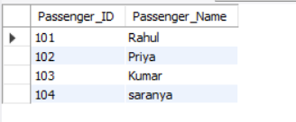

VIEW - 2
INSERT INTO v1
VALUES (105,'Akash');
DELETE FROM v1
WHERE Passenger_ID=105;
SELECT * FROM v1;
OUTPUT:
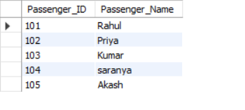
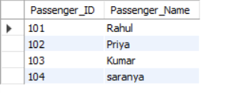

INDEX - 1
CREATE INDEX index1
ON Passenger(Passenger_Name);
SELECT Passenger_Name
FROM Passenger
WHERE Passenger_Name LIKE 'R%';
DROP INDEX index1 ON Passenger;

OUTPUT:
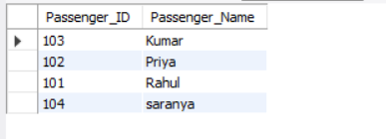

INDEX - 2
CREATE INDEX index2
ON Passenger(Passenger_ID);
SELECT Passenger_Name
FROM Passenger
WHERE Passenger_ID=101;
OUTPUT:
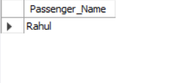

RESULT:
Thus, VIEW and INDEX were successfully created and verified in the Flight Reservation System database.

